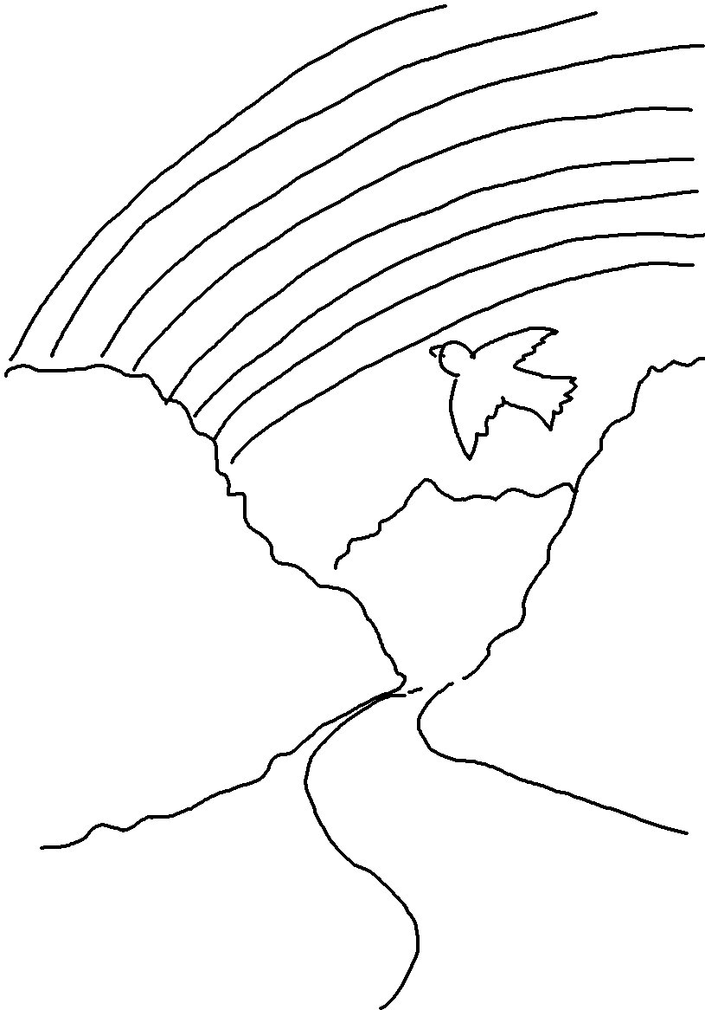
In Genesis 9:16_{NLT} God says, "When I see the _ _ _ _ _ _ _ in the clouds, I will remember the eternal covenant between _ _ _ and _ _ _ _ _ living creature on earth."

